- Purpose
The purpose of this document is to establish a structured process for the creation, review, approval, execution, and documentation of the Inspection Test Plan (ITP) within our project workflow. This ensures that all project requirements, quality standards, and client expectations are systematically met through coordinated inspections and timely communication.

- Scope
This workflow applies to all EPC and BESS projects.

- Responsibilities

ROLE | RESPONSILITIES
Site Quality Manager (SQM) | Create ITP  Collect and incorporate team feedback  Lead FAI with project team and client  Update ITP with project changes  Manage and track inspections  Submit completed inspections to clients
Regional Quality Manager (RQM) | Establish timeline for ITP creation  Approve ITP  Provide feedback and guidance
Project Team | Review ITP and provide feedback  Participate in FAIs
Client | Participate in FAIs  Receive submitted completed inspections

- Process Map
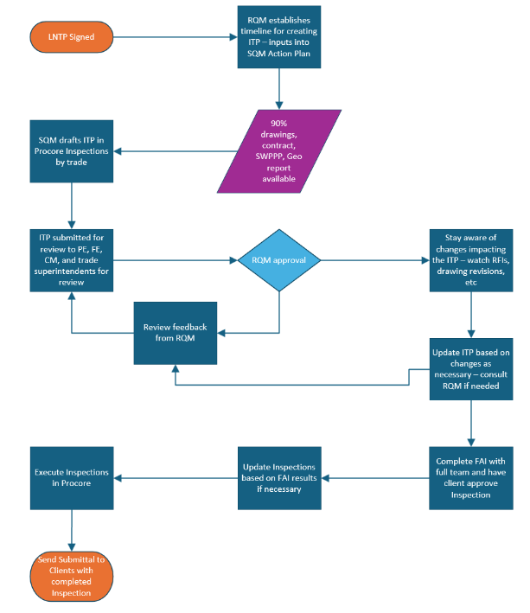

- Procedure
  - Timeline Establishment
    - The RQM establishes the timeline for the ITP creation from the Limited Notice to Proceed (LNTP).
  - Inputs & Drafting
    - SQM gathers necessary inputs (drawings, contract, SWPPP, geo reports).
    - When 90% drawings are available, SQM drafts the ITP using all available resources
  - Project Team Review
    - Submit the draft ITP to PE, FE, CM, and trade superintendents for review.
    - Consider the feedback received from the project team and make necessary updates to ITP.
  - ITP Approval and Ongoing Updates
    - Submit project team reviewed ITP draft to the RQM for approval.
    - SQM must stay aware of any project changes (e.g., RFIs, drawing revisions) that may impact the ITP.
    - SQM has the authority to update the ITP as needed based on project changes; consult RQM on changes as needed.
  - First Article Inspection (FAI)
    - Conduct FAI with the full project team and client.
    - Gather team feedback on the inspection, evaluate the process, and get client approval on the Inspection.
    - Update the ITP for future inspections.
    - Completed FAI in Procore and document client participation and approval.
  - Inspection Execution
    - Continue to stay aware of project changes and update ITP as necessary.
    - Inspections are executed with the ITP in Procore
    - Submit the completed ITP and inspection documentation to the client for review and acceptance.

- Revision Table

REV. # | REV. DATE | DESCRIPTION | APPROVER
00 | 1/12/2026 | Initial Release | Jonathan Macdonald

